Von Neumann Architecture and Modern Computers:

Von Neumann Architecture and Modern Computers---------

Computer:

* Reads a certain set of instruction and repeats
* Memory can be a program and/or data
* A program is a sequence of machine instruction that is stored in memory
  + Each machine codes instructions that occupied in one or more memory locations
  + A consist pattern of 0s and 1s determine the operation to be performed by the CPU

Arithmetic logic unit (ALU):

* reads numbers and add them

Registers:

* Memory for the laptop
* Operations occur faster when the two registers are nearby
* The more memory you have the slower the memory gets
* Fastest memory around 1 clock sec
* PI has R0-15
* Can use up to R11 and rest are special
* On a 64 bit chip, they will have R1-32
* ARM V6 is a 32 bit processor

RAM:

* Needs to refreshed very often
* Static faster than dynamic
* Slower than Registers
* 13-15 clock sec

Hard drive:

* Used for storage information

Cache:

* Bigger than register and slower than register
* Used to get recent memory
* Levels of cash:
  + 1:
  + 2:
  + 3:

CPU:

* Goes to memory and get instruction
* Program counter: grab instruction and does it
  + Similar to a loop
* Cash this processes when doing it over it gain

Instruction decoder:

* Decodes the instruction

Von Neumann Architecture:

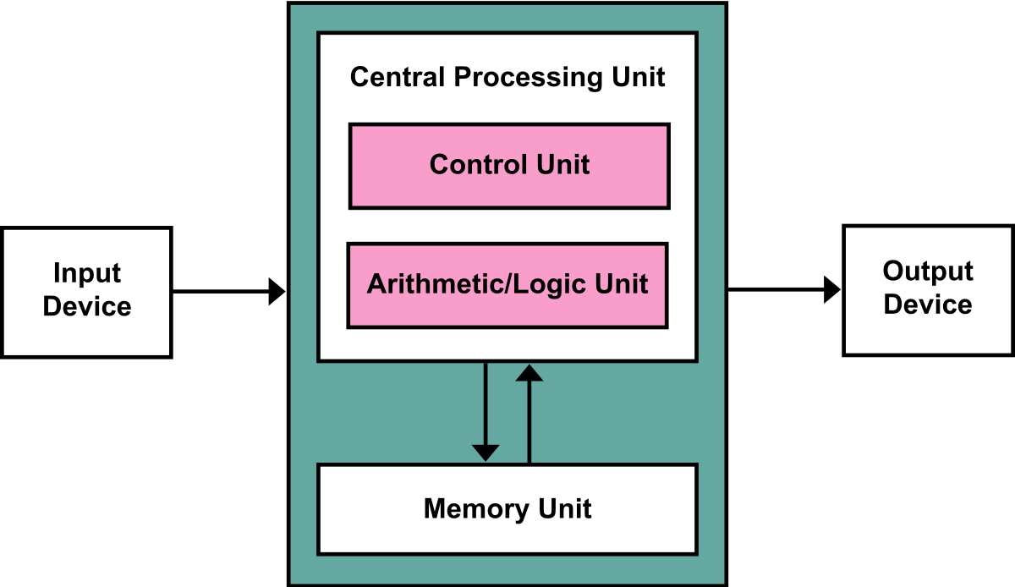

Address bus:

* Tells where to put the memory (goes out uni-directional manner)

Data bus:

* Goes multi direction
* Wants the data bus to be 32 bits since it will take less time
* Data bus and ALU for our laptops are 64 bits

Average:

* Most amount of location for 32 bit is around 4 four billion
* 2.4 GHz average clock speed for PI
* 2.4 billion operation per sec
* Will take around 2 secs for code like this to run:
  + .loop2:
    - Add R0,R0,#1
    - @CPSR = Z = zero (true) = N(negative)(False) = C(carry=overflow)
    - BNE .loop2 (will do it until z = true)
    - B .loop2
    - 2^10=5024
    - 2^32 four billion
    - Most amount of location for 32 bit is around 4 four billion
    - 2.4 GHz average clock speed
    - 2.4 billion operation per sec
    - Will take around 2 secs